Project Report: Electric Bus Ticket Generator
Submitted by:- Piyush Chaudhary (65), Nikhil Kumar (66), Shubhanshu Kumar Srivastava (63)
(KF22FU)

Description:-

The Electric Bus Ticket Generator is a software application developed in C language that generates and prints tickets for electric buses. The system allows passengers to purchase their tickets using an automated ticket vending machine. The ticket machine is connected to a database that contains information about bus routes, schedules, and fares. Passengers can select their destination and the system will generate a ticket with the appropriate fare. The system also generates reports on ticket sales, passenger counts, and revenue generated.

Implementation:-
The program will have a main function that will call other functions for displaying available
buses, adding new buses, booking and canceling seats, and deleting/updating bus details. The program will use
structures to store data for each bus, including their bus number, destination, fare, and
number of seats available.

Module Explanation:-

- Displaying Available Buses:-
The program will read data from the `bus.txt` file and display a list of available buses,
including their bus number, destination, fare, and number of seats available.

- Adding New Buses:-
The program will prompt the user to enter details for a new bus, including their bus number,
destination, fare, and number of seats available. The program will then add the new bus to the
`bus.txt` file.

- Booking and Cancelling Seats:-
The program will prompt the user to enter the bus number and the number of seats they want
to book or cancel. If the user wants to book seats, the program will check if there are enough
seats available and update the `bus.txt` file. If the user wants to cancel seats, the program will
check if the user has booked seats on the bus and update the `bus.txt` file.

- Deleting/Updating Bus Details
The program will prompt the user to enter the bus number for the bus they want to delete or
update. If the user wants to delete the bus, the program will remove the bus from the `bus.txt`
file. If the user wants to update the bus details, the program will prompt the user to enter the
new details and update the `bus.txt` file.

DFD (Level 0):-

Level 0 DFD of the Electric Bus Ticket Generator is as follows:-
+--------------------------+
| Passenger |
+--------------------------+
|
| Purchase Ticket
|
+--------------------------+
| Ticket Vending Machine|
+--------------------------+
|
| Generate Ticket
|
+--------------------------+
| Electric Bus Ticket |
| Generator |
+--------------------------+
|
| Update Database
|
+--------------------------+
| Database Management|
+--------------------------+
In the above DFD, the passenger purchases a ticket using the ticket vending machine. The ticket vending machine generates a ticket by communicating with the Electric Bus Ticket Generator. The Electric Bus Ticket Generator updates the database with the information provided. The ticket has necessary details printed on it.

Code:-
#include <stdio.h>
#include <string.h>
#include <stdlib.h>

typedef struct Bus
{
// attributes of a bus
int bus_id;
int bus_seats[33];
int no_of_seat_in_bus;
float bus_fare;
char bus_route[100];
char bus_name[50];
char bus_time[12];

// pointer to generate bus obj function
struct Bus (*generate_bus)(int id, char bus_name[], char bus_time[], float bus_fare, char bus_route[], struct Bus *bus);
} BUS;

// Generate Bus Function
BUS GenerateBusObj(int id, char bus_name[], char bus_time[], float bus_fare, char bus_route[], BUS *bus)
{
// MODULE 2

// assigning values
bus->bus_id = id;
strcpy(bus->bus_name, bus_name);
strcpy(bus->bus_time, bus_time);
strcpy(bus->bus_route, bus_route);
bus->bus_fare = bus_fare;

// assigning bus seats their number
int max_seat_bus = 33;

bus->no_of_seat_in_bus = max_seat_bus;

for (int i = 0; i < max_seat_bus; i++)
{
bus->bus_seats[i] = 0;
}

return *bus;
}

// MODULE 2
// declarations
// Bus object
BUS bus;
// Bus object pointer
BUS *bus_ptr = &bus;
int max_seat_in_bus = 33;
int num_of_buses;

void Add_New_Bus()
{
// MODULE 2
// Initialising the function pointer
bus.generate_bus = GenerateBusObj;

// taking input for number of buses
printf("-----> Enter number of buses you want to add:- \n");
scanf("%d", &num_of_buses);

// Allocating memory for buses
BUS *buses = (BUS *)malloc(num_of_buses * sizeof(BUS));

for (int i = 0; i < num_of_buses; i++)
{
// variables
int bus_id;
char bus_name[50];
char bus_time[12];
float bus_fare;
char bus_route[100];

// taking inputs
printf("Enter Bus Id:- \n");
scanf("%d", &bus_id);
getchar();
printf("Enter Bus Name:- \n");
fgets(bus_name, 50, stdin);
printf("Enter Bus Time (in the format HH:MM AM/PM):- \n");
fgets(bus_time, 12, stdin);
printf("Enter Bus Fare:- \n");
scanf("%f", &bus_fare);
getchar();
printf("Enter Bus Route Name (Remember the route name you typed as it will help you get available buses for a route):- \n");
fgets(bus_route, 100, stdin);

// Storing the bus in the allocated array
buses[i] = (bus.generate_bus)(bus_id, bus_name, bus_time, bus_fare, bus_route, bus_ptr);
}
}

// Available Buses for a route
void Get_Bus_For_A_Route(BUS *buses)
{
// MODULE 1
// variables
char route[100];
getchar();
printf("Enter route name:- \n");
fgets(route, 100, stdin);
printf("\n");
int bus_available = 0;

// Searching buses for the given route
for (int i = 0; i < num_of_buses; i++)
{

if (strcmp(buses[i].bus_route, route) == 0)
{
printf("Bus ID:- %d\n", buses[i].bus_id);
buses[i].bus_name[strcspn(buses[i].bus_name, "\n")] = '\0';
printf("Bus name:- %s\n", buses[i].bus_name);
printf("Bus fare:- %f\n", buses[i].bus_fare);
buses[i].bus_route[strcspn(buses[i].bus_route, "\n")] = '\0';
printf("Bus route:- %s\n", buses[i].bus_route);
printf("No. of seat in bus:- %d\n", buses[i].no_of_seat_in_bus);
buses[i].bus_time[strcspn(buses[i].bus_time, "\n")] = '\0';
printf("Bus time:- %s\n", buses[i].bus_time);
bus_available = 1;
}
}

// If no bus found
if (!bus_available)
{
printf("\n");
printf("-----> -----> -----> -----> -----> -----> 'No buses available'\n");
printf("\n");
}
}

// MODULE 3
// print available seats function declaration
void Dipslay_Bus_Layout(BUS *buses, int bus_id, char bus_name[]);

// MODULE 3
// Book Seat in the bus
void Book_Seat(BUS *buses)
{
// variables
int option;
int bus_id;
char bus_name[50];
int seat_no;

printf("\n");
printf("-----> -----> -----> -----> -----> -----> (You can search for the bus by either entering the 'Bus ID' OR 'Bus Name')\n");
printf("1. Search bus by Bus ID\n");
printf("2. Search bus by Bus Name\n");
printf("Enter the option number:- \n");
scanf("%d", &option);
printf("\n");

switch (option)
{
case 1:
printf("Enter Bus ID:-\n");
scanf("%d", &bus_id);
Dipslay_Bus_Layout(bus_ptr, bus_id, bus_name);
printf("\n");
printf("\n");
printf("Enter seat number to book:- \n");
scanf("%d", &seat_no);
for (int i = 0; i < num_of_buses; i++)
{
if (buses[i].bus_id == bus_id)
{
buses[i].bus_seats[seat_no - 1] = 1;
}
}
break;

case 2:
printf("Enter Bus Name:-\n");
getchar();
fgets(bus_name, 50, stdin);
Dipslay_Bus_Layout(bus_ptr, bus_id, bus_name);
printf("\n");
printf("\n");
printf("Enter seat number to book:- \n");
scanf("%d", &seat_no);
for (int i = 0; i < num_of_buses; i++)
{
if (strcmp(buses[i].bus_name, bus_name) == 0)
{
buses[i].bus_seats[seat_no - 1] = 1;
}
}
break;

default:
printf("Please enter a valid option number\n");
break;
}
}

// MODULE 3 and 4
// Print bus top view
void Dipslay_Bus_Layout(BUS *buses, int bus_id, char bus_name[])
{
// MODULE 3
// print available seats
int i;
int j;
int bus_pos_in_array;
printf(" Window\n");
printf("------------------------\n");

for (int k = 0; k < max_seat_in_bus; k++)
{
if (buses[k].bus_id == bus_id)
{
bus_pos_in_array = k;
break;
}
else if (strcmp(buses[k].bus_name, bus_name) == 0)
{
bus_pos_in_array = k;
break;
}
}

for (i = 0, j = 0; i < max_seat_in_bus; i++)
{
// booked_seats[i] == 0
if (buses[bus_pos_in_array].bus_seats[i] == 0)
{
if (i + 1 <= 9)
{
printf("%d ", i + 1);
}
else if (i == 16)
{
printf(" (Bus Top View) %d |", i + 1);
printf("\n");
}
else
{

printf("%d ", i + 1);
}
if (i != 16)
{
j++;
}
if (j == 8)
{
printf("|");
printf("\n");
}
else if (j == 16)
{
printf("|");
printf("\n");
j = 0;
}
}
else
{
if (i + 1 <= 9)
{
printf("B ");
}
else if (i == 16)
{
printf(" (Bus Top View) ~ |");
printf("\n");
}
else
{
printf("B ");
}
if (i != 16)
{
j++;
}
if (j == 8)
{
printf("|");
printf("\n");
}
else if (j == 16)
{
printf("|");
printf("\n");
j = 0;
}
}
}
printf("------------------------\n");
printf(" Window\n");
}

// MODULE 4
void Cancel_Seat(BUS *buses)
{
// variables
int option;
int bus_id;
char bus_name[50];
int seat_no;

printf("\n");
printf("-----> -----> -----> -----> -----> -----> (You can search for the bus by either entering the 'Bus ID' OR 'Bus Name')\n");
printf("1. Search bus by Bus ID\n");
printf("2. Search bus by Bus Name\n");
printf("Enter the option number:- \n");
scanf("%d", &option);
printf("\n");

switch (option)
{
case 1:
printf("Enter Bus ID:-\n");
scanf("%d", &bus_id);
Dipslay_Bus_Layout(bus_ptr, bus_id, bus_name);
printf("\n");
printf("\n");
printf("Enter your booked seat number to cancel:- \n");
scanf("%d", &seat_no);
for (int i = 0; i < num_of_buses; i++)
{
if (buses[i].bus_id == bus_id)
{
buses[i].bus_seats[seat_no - 1] = 0;
}
}
break;

case 2:
printf("Enter Bus Name:-\n");
getchar();
fgets(bus_name, 50, stdin);
Dipslay_Bus_Layout(bus_ptr, bus_id, bus_name);
printf("\n");
printf("\n");
printf("Enter your booked seat number to cancel:- \n");
scanf("%d", &seat_no);
for (int i = 0; i < num_of_buses; i++)
{
if (strcmp(buses[i].bus_name, bus_name) == 0)
{
buses[i].bus_seats[seat_no - 1] = 0;
}
}
break;

default:
printf("Please enter a valid option number\n");
break;
}
}

// MODULE 5
void Delete_Update_Bus_Detail(BUS *buses, int bus_pos_in_array)
{
// variables
int option;
char bus_name[50];
int bus_id;
float bus_fare;
char bus_route[100];
char bus_time[15];

// menu
printf("choose the option to change that particular detail:- \n");
printf("1. Bus Name\n");
printf("2. Bus ID\n");
printf("3. Bus Fare\n");
printf("4. Bus Route\n");
printf("5. Bus Time\n");
scanf("%d", &option);

switch (option)
{
case 1:
printf("Enter new name for the bus:- \n");
getchar();
fgets(bus_name, 50, stdin);
strcpy(buses[bus_pos_in_array].bus_name, bus_name);
printf("Bus name successfully updated\n");
break;

case 2:
printf("Enter new bus ID for the bus:- \n");
getchar();
scanf("%d", &bus_id);
buses[bus_pos_in_array].bus_id = bus_id;
printf("Bus ID successfully updated\n");
break;

case 3:
printf("Enter new bus fare for the bus:- \n");
getchar();
scanf("%f", &bus_fare);
buses[bus_pos_in_array].bus_fare = bus_fare;
printf("Bus fare successfully updated\n");
break;

case 4:
printf("Enter new bus route for the bus:- \n");
getchar();
fgets(bus_route, 100, stdin);
strcpy(buses[bus_pos_in_array].bus_route, bus_route);
printf("Bus route successfully updated\n");
break;

case 5:
printf("Enter new bus time for the bus:- \n");
getchar();
fgets(bus_time, 15, stdin);
strcpy(buses[bus_pos_in_array].bus_time, bus_time);
printf("Bus timing successfully updated\n");
break;

default:
printf("Please enter the listed option number only.\n");
break;
}
}

// MODULE 5
void Search_Bus_For_Update_Operation(BUS *buses)
{
// variables
int option;
int bus_id;
char bus_name[50];
int bus_pos_in_array;

printf("\n");
printf("-----> -----> -----> -----> -----> -----> (You can search for the bus by either entering the 'Bus ID' OR 'Bus Name')\n");
printf("1. Search bus by Bus ID\n");
printf("2. Search bus by Bus Name\n");
printf("Enter the option number:- \n");
scanf("%d", &option);
printf("\n");

switch (option)
{
case 1:
printf("Enter Bus ID:-\n");
scanf("%d", &bus_id);
printf("\n");
printf("\n");
for (int i = 0; i < num_of_buses; i++)
{
if (buses[i].bus_id == bus_id)
{
bus_pos_in_array = i;
buses[i].bus_name[strcspn(buses[i].bus_name, "\n")] = '\0';
printf("Bus name:- %s\n", buses[i].bus_name);
printf("Bus ID:- %d\n", buses[i].bus_id);
printf("Bus fare:- %f\n", buses[i].bus_fare);
buses[i].bus_route[strcspn(buses[i].bus_route, "\n")] = '\0';
printf("Bus route:- %s\n", buses[i].bus_route);
buses[i].bus_time[strcspn(buses[i].bus_time, "\n")] = '\0';
printf("Bus time:- %s\n", buses[i].bus_time);
printf("\n");
break;
}
}
Delete_Update_Bus_Detail(bus_ptr, bus_pos_in_array);
break;

case 2:
printf("Enter Bus Name:-\n");
fgets(bus_name, 50, stdin);
printf("\n");
for (int i = 0; i < num_of_buses; i++)
{
if (strcmp(buses[i].bus_name, bus_name) == 0)
{
bus_pos_in_array = i;
printf("Bus name:- %s", buses[i].bus_name);
printf("Bus ID:- %d\n", buses[i].bus_id);
printf("Bus fare:- %f\n", buses[i].bus_fare);
printf("Bus route:- %s", buses[i].bus_route);
printf("Bus time:- %s\n", buses[i].bus_time);
break;
}
}
Delete_Update_Bus_Detail(bus_ptr, bus_pos_in_array);
break;

default:
printf("Please enter a valid option number\n");
break;
}
}

// deallocating dynamically allocated buses
void cleanup(BUS *buses, int num_of_buses)
{
for (int i = 0; i < num_of_buses; i++)
{
free(buses[i].generate_bus);
}
free(buses);
printf(" Dynamically allocated memory was deallocated\n");
buses = NULL;
}

int main()
{
// MAIN MENU
// variable
int option;

while (option)
{
Main_Menu:
printf(" Electronic Bus Ticket Generator\n");
printf("1. Available buses for a route\n");
printf("2. Add new bus\n");
printf("3. Book seat\n");
printf("4. Cancel seat\n");
printf("5. Delete/Update a bus deatil\n");
printf("6. Go to Menu\n");
printf("7. Exit\n");
printf(" Made by Piyush Chaudhary, Nikhil Kumar, Subhanshu Kumar Srivastava");
printf(" (K22FU)\n");
printf("Enter the option number:- \n");
scanf("%d", &option);

switch (option)
{

case 1:
Get_Bus_For_A_Route(bus_ptr);
break;

case 2:
Add_New_Bus();
printf("-----> -----> -----> -----> -----> -----> 'Bus seccessfully added'\n");
printf("\n");
break;

case 3:
Book_Seat(bus_ptr);
printf("\n");
printf("-----> -----> -----> -----> -----> -----> 'Seat seccessfully booked'\n");
break;

case 4:
Cancel_Seat(bus_ptr);
printf("\n");
printf("-----> -----> -----> -----> -----> -----> 'Seat seccessfully canceled'\n");
break;

case 5:
Search_Bus_For_Update_Operation(bus_ptr);
printf("\n");
printf("-----> -----> -----> -----> -----> -----> 'Bus details successfully updated'\n");
break;

case 6:
goto Main_Menu;
break;

case 7:
option = 0;
break;

default:
printf("Please enter a valid option number.\n");
goto Main_Menu;
break;
}
}

cleanup(bus_ptr, num_of_buses);
}

Snapshots:-
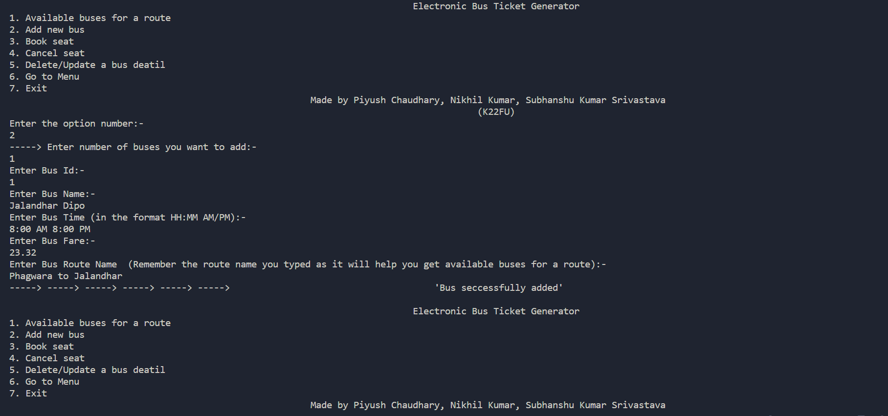

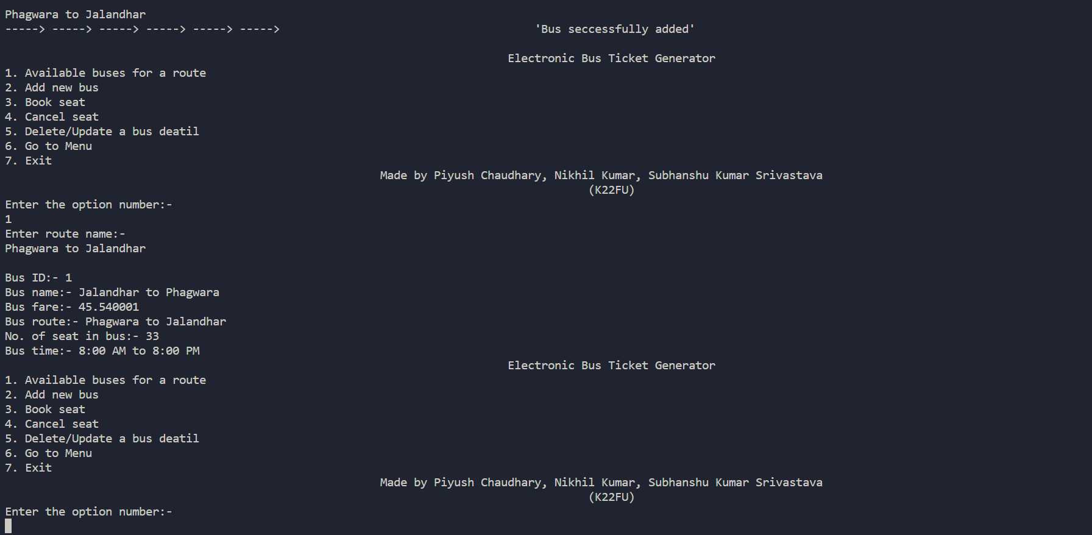

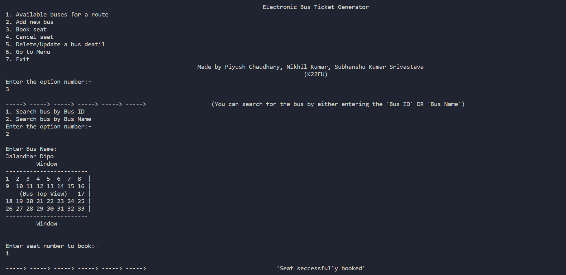

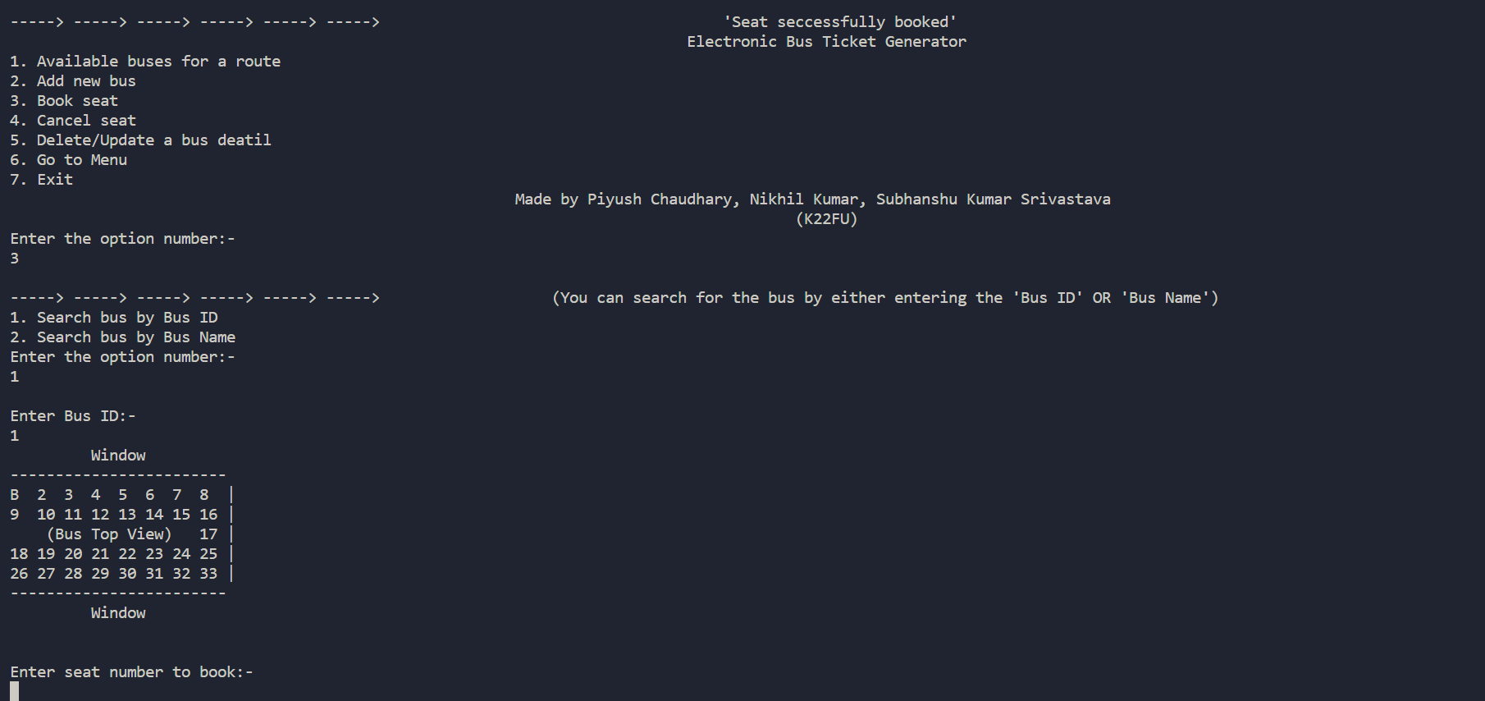

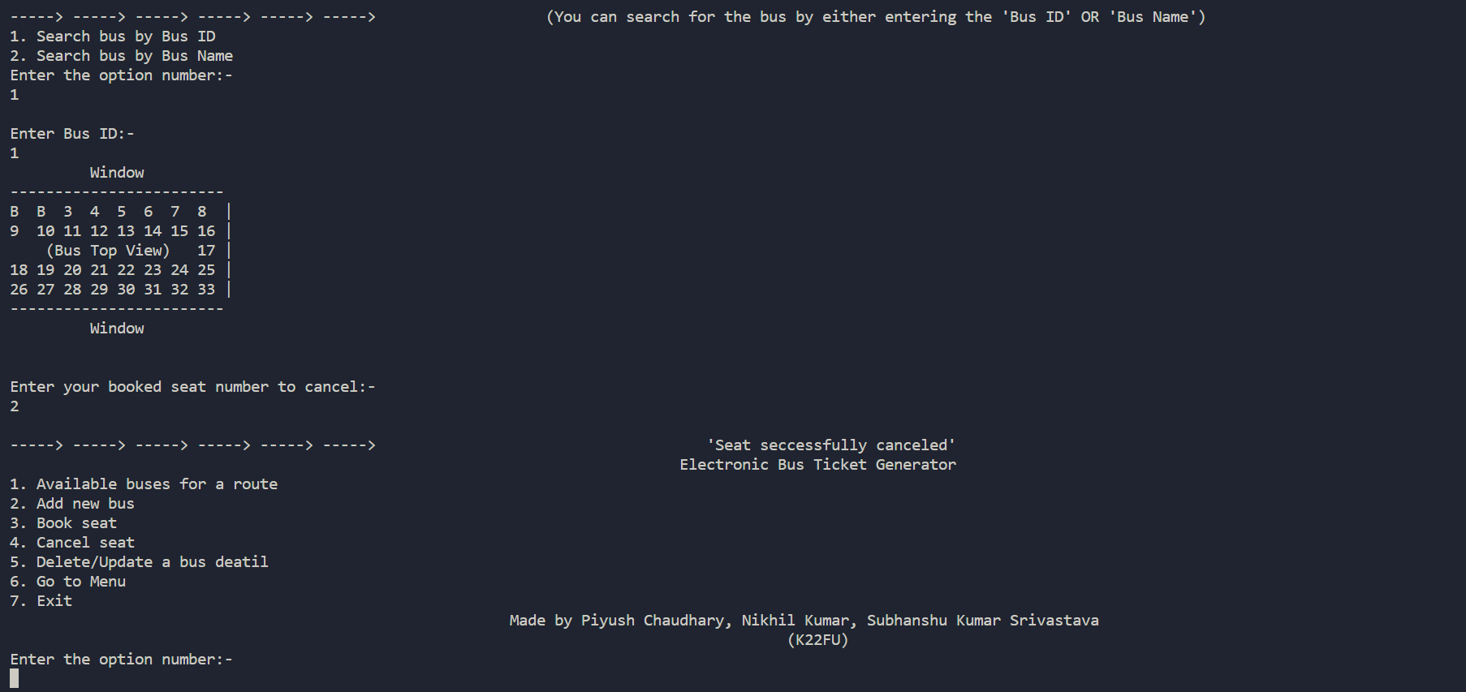

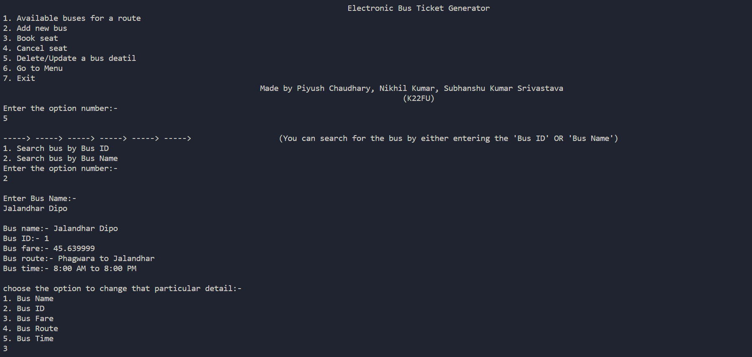

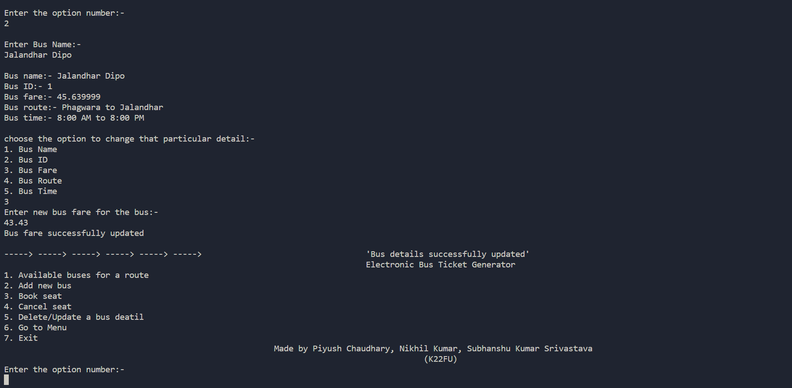

Conclusion:-
The electric bus ticket generator project has been successfully implemented using the C
programming language with file handling. The program has modules for displaying available
buses, adding new buses, booking and cancelling seats, and deleting/updating bus details. The
program uses file handling to read and write data to a `bus.txt` file, which contains details for
each bus, including their bus number, destination, fare, and number of seats available. The
program uses structures to store data for each bus.

